1. **STAR TUP992**

**Troubleshooting and hotfixes.**

1. **Are you able to find printer on any COM port in “Star Micronics Printer Utility”.**
2. **Yes- continue troubleshooting, remember on which com port it was faound.**
3. **No- Check paper alignment, paper sensor and cables on the printer.**
4. **Printer is being detected however it won’t print on vista.**

**-Check if there is correct comport and atm name in vss Hardware cofig.**

**-check if there is correct comport set in Ocius,**

Start troubleshooting by:

Relog on to administrator.

Open “Star Microncs Printer Ultility”

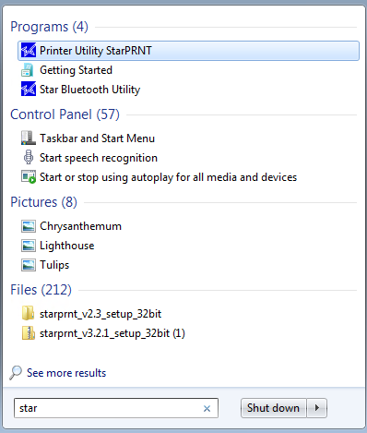

Click “Check” in “current connection”

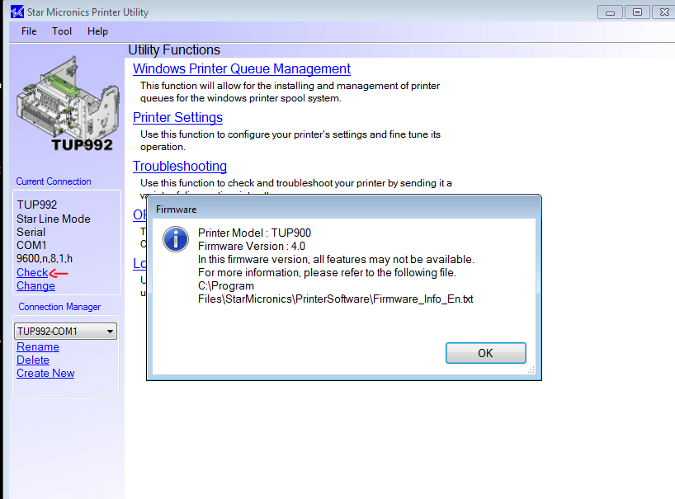

If the printer is not being detected this is what will come up:

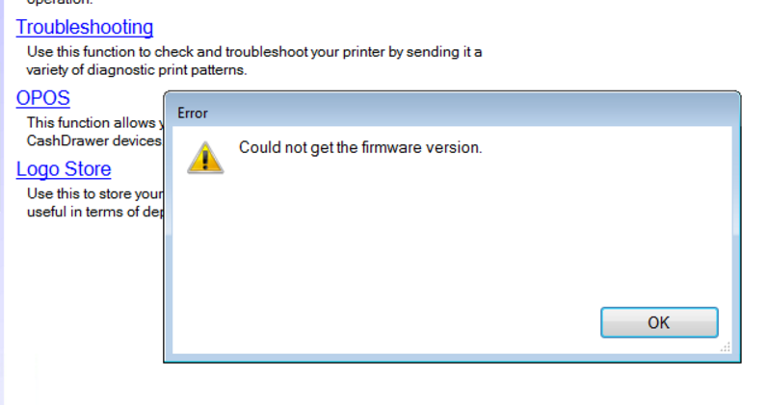

In this case pick “change”



Select TUP992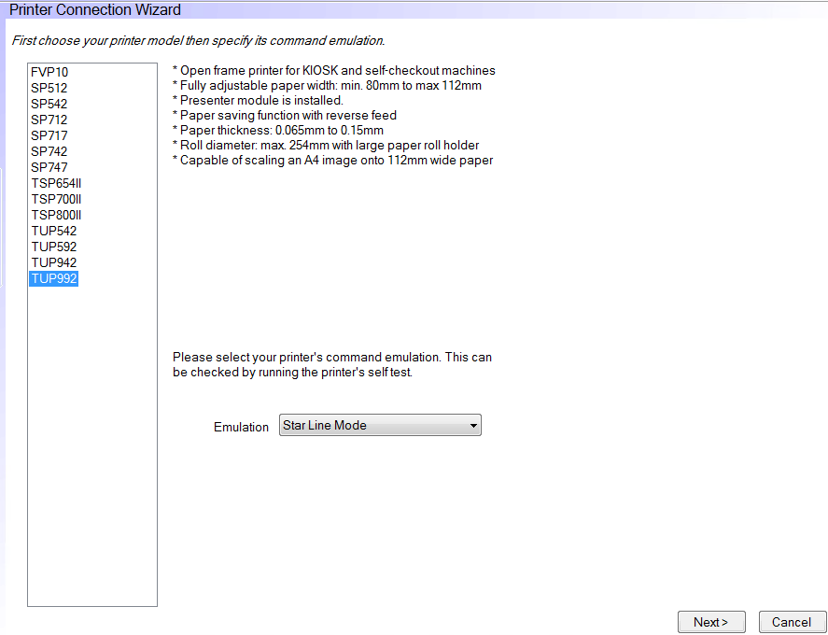

Select serial and select other comports to test if printer is connected to them (com01, com02 etc.)

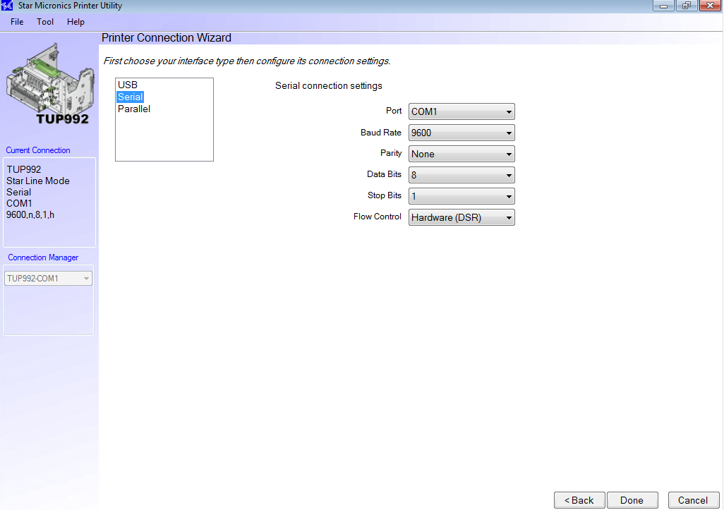

After that select “check”.

If the printer is not being detected on any comport:

1. Check if the paper is aligned properly and there are no issues with the paper sensor.

This is very common issue. This model of a printer will show as OFFLLINE if paper is aligned incorrectly.

1. Check the cables that go to the printer.

If the printer is being detected on any com, however it won’t print on vista:

1. Check if the COM port detected in Star utility is set to the same one on ocius.

Open “Ocius for PC” -> “App Settings”- > more-> print settings-> printer->more-> com port printer->

Select the same COM that printer is currently connected to.

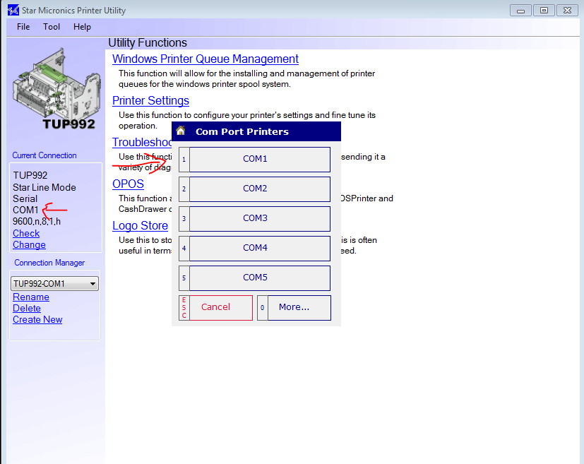

After that check if the same COM is set up in VssClientHardwareConfig.xml

( location to file C:\VISTA\VistaKiosk\Config)